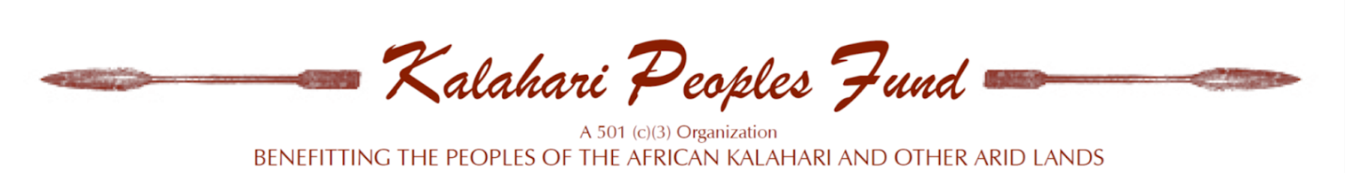

Project Proposal Cover Page
Date of application:
Amount requested:

1. What is your name?
2. Briefly describe the proposal (250 words maximum)
3. Where will this project take place? (include ethnic/linguistic group, village name, region, country)
4. Name of community affiliation:
5. What date should this project begin?
7. By what date will this project be completed?

Proposal Questions
Background/History:
- What background and history of your community and this project will help us to understand the proposal?
Purpose:
- What is the purpose of the proposal?
- Why is this project important for your community?
Goals and objectives:
- What are the specific goals that this project aims to meet?
Work Plan:
- What materials and activities would this project involve?
- What is the estimated timeline for this project? We believe this project will take about 1 year to complete.
- What people are to be involved with this project?
  - Please list specific individuals and how many.
Urgency:
- How urgent is the need for this project to begin?
Budget:
- How much will this project cost?
- How would the money for this project be used to complete it? (Budget Outline)

Supporting Documentation

Letter of reference/support:
- Please provide a character and/or work reference from someone who knows your potential to complete this project.

